Event / Message Resource

📝Definition
# Source: AI Source: Provided by: [Data Path: Persons Table -> ID Column: 1, Name_En Column: Motasem Essam] -> From: [ChatGPT] on [1/23/2026]
An Event / Message Resource represents a communication unit used to transfer information between different parts of a system, especially in event-driven or distributed architectures.
👉 Think of it as a notification or signal that something happened, or a message carrying data from one component to another.

🔑 Key Points
# Source: AI Source: Provided by: [Data Path: Persons Table -> ID Column: 1, Name_En Column: Motasem Essam] -> From: [ChatGPT] on [1/23/2026]
- Used for communication between components
- Can represent something that happened (Event) or a request/data transfer (Message)
- Enables loose coupling between parts of the system
- Common in event-driven systems, microservices, queues

🧱 Examples

1️⃣ Event Example
# Source: AI Source: Provided by: [Data Path: Persons Table -> ID Column: 1, Name_En Column: Motasem Essam] -> From: [ChatGPT] on [1/23/2026]
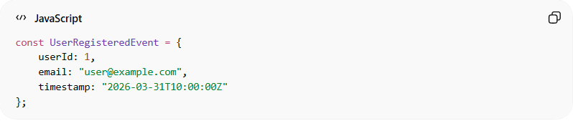
const UserRegisteredEvent = {
userId: 1,
email: "user@example.com",
timestamp: "2026-03-31T10:00:00Z"
};
👉 Meaning:
- “A user has been registered”
- Other parts of the system can react (send email, log activity, etc.)

2️⃣ Message Example (Queue / Command)
# Source: AI Source: Provided by: [Data Path: Persons Table -> ID Column: 1, Name_En Column: Motasem Essam] -> From: [ChatGPT] on [1/23/2026]
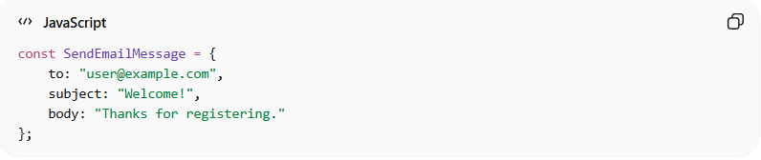
const SendEmailMessage = {
to: "user@example.com",
subject: "Welcome!",
body: "Thanks for registering."
};
👉 Meaning:
- A task/message sent to another service (e.g., email service)

3️⃣ Laravel Example (Event)
# Source: AI Source: Provided by: [Data Path: Persons Table -> ID Column: 1, Name_En Column: Motasem Essam] -> From: [ChatGPT] on [1/23/2026]
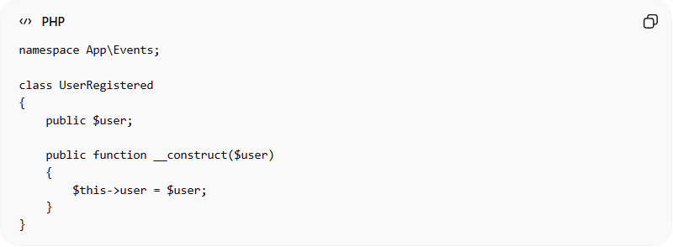
namespace App\Events;

class UserRegistered
{
public $user;

public function __construct($user)
{
$this->user = $user;
}
}
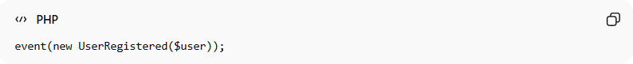
event(new UserRegistered($user));
👉 This event can trigger:
- Send welcome email
- Log activity
- Notify admins

4️⃣ Laravel Example (Listener)
# Source: AI Source: Provided by: [Data Path: Persons Table -> ID Column: 1, Name_En Column: Motasem Essam] -> From: [ChatGPT] on [1/23/2026]
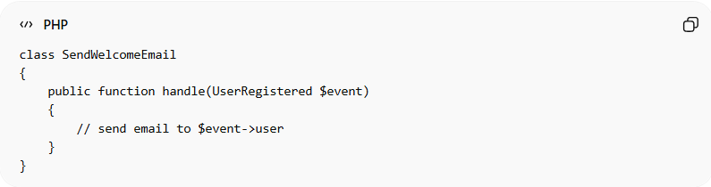
class SendWelcomeEmail
{
public function handle(UserRegistered $event)
{
// send email to $event->user
}
}

❌ Bad Example
# Source: AI Source: Provided by: [Data Path: Persons Table -> ID Column: 1, Name_En Column: Motasem Essam] -> From: [ChatGPT] on [1/23/2026]
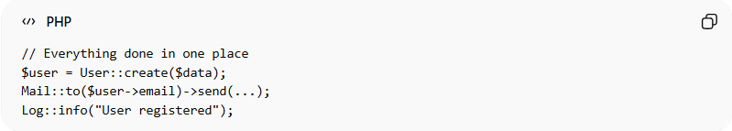
// Everything done in one place
$user = User::create($data);
Mail::to($user->email)->send(...);
Log::info("User registered");
Problems:
- Tightly coupled logic ❌
- Hard to extend ❌
- Violates separation of concerns ❌

✅ Good Example
# Source: AI Source: Provided by: [Data Path: Persons Table -> ID Column: 1, Name_En Column: Motasem Essam] -> From: [ChatGPT] on [1/23/2026]
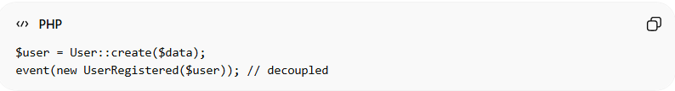
$user = User::create($data);
event(new UserRegistered($user)); // decoupled
- Other actions handled independently via listeners ✅
- Easy to extend (add new listeners) ✅
- Clean and maintainable ✅

🔄 Event vs Message
# Source: AI Source: Provided by: [Data Path: Persons Table -> ID Column: 1, Name_En Column: Motasem Essam] -> From: [ChatGPT] on [1/23/2026]
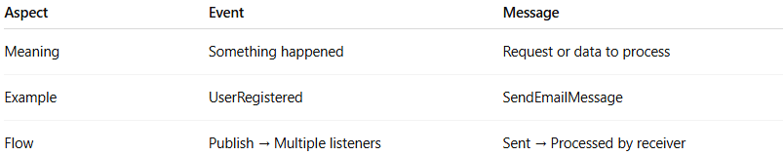
Aspect | Event | Message
Meaning | Something happened | Request or data to process
Example | UserRegistered | SendEmailMessage
Flow | Publish → Multiple listeners | Sent → Processed by receiver

🔄 Relation to Other Resources
# Source: AI Source: Provided by: [Data Path: Persons Table -> ID Column: 1, Name_En Column: Motasem Essam] -> From: [ChatGPT] on [1/23/2026]
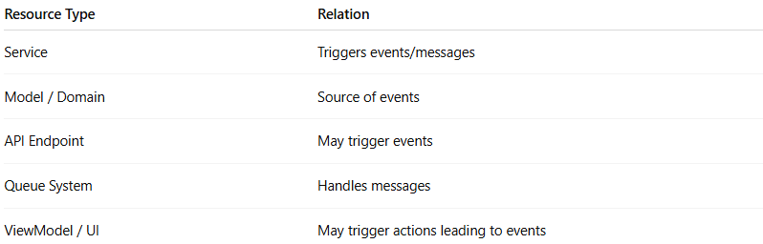
Resource Type | Relation
Service | Triggers events/messages
Model / Domain | Source of events
API Endpoint | May trigger events
Queue System | Handles messages
ViewModel / UI | May trigger actions leading to events

💡 Key Idea
# Source: AI Source: Provided by: [Data Path: Persons Table -> ID Column: 1, Name_En Column: Motasem Essam] -> From: [ChatGPT] on [1/23/2026]
Event / Message Resources enable decoupled communication, allowing systems to react and scale independently.

🧾 Summary
# Source: AI Source: Provided by: [Data Path: Persons Table -> ID Column: 1, Name_En Column: Motasem Essam] -> From: [ChatGPT] on [1/23/2026]
- Represents communication between components
- Supports event-driven and distributed systems
- Improves decoupling and scalability
- Used with events, queues, and messaging systems

